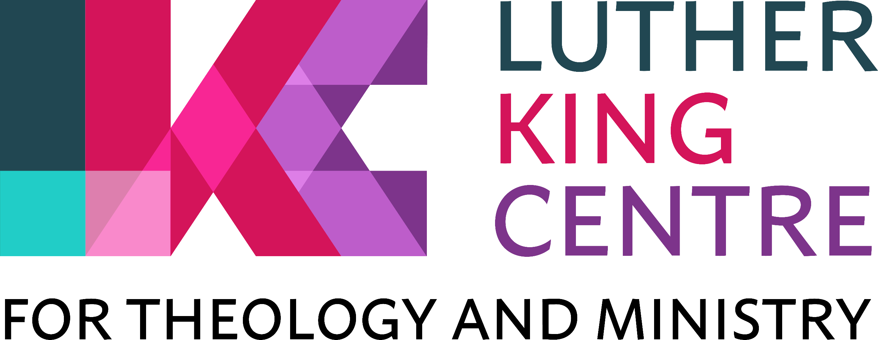
Using Moodle
- Moodle can be accessed at https://lkh.commonawards.org/ You can access Moodle wherever the Internet is available (inside and outside LKC).

- An account will be created for you once you have formally registered for a course, module or programme. You will receive an e-mail containing your initial ‘first-time’ log in details (an example of this email can be found on page three of this guidance document). Your username will be in the standard format of firstname.lastname (eg, joseph.bloggs)

- Click on the link contained in the email where you will be directed to change your password. The password you choose needs to be at least 8 characters long and must include: at least one capital letter, at least one lower case letter, at least one digit and at least one non-alphanumeric character (i.e. a symbol, such as * ? . & ^ ! etc.).

- You will then be able to log in to Moodle with your username and chosen password. If you don’t receive the email, check it has not gone into your ‘junk’ email folder. Speak to Registry Office staff or the Librarian if you have problems confirming your registration.

- Once you have accessed your account, please also upload a photo of yourself in your “My profile” area – click on your name in the top right-hand corner of the homepage, click “Edit profile”, then scroll down and click “User picture”. You can then upload your photo in the box with the blue arrow.

- Moodle is the place to go to access all your modules and all other key documents and information relating to your studies at LKC, under the following headings on the main menu at the top of your screen:
- Luther King Centre: - this is the main area for all students and users to access information regarding Luther King Centre.
  - Durham University Common Awards: - click here to access and search the full list of courses for those studying on our ‘Theology, Ministry & Mission’ programmes, our Chaplaincy Studies MA, and those studying modules on our Open Learning programme in the current academic year.
  - University of Manchester: - click here to access and search the list of courses for those continuing to study with us as part of the BA, MA and Research programme in Contextual Theology under the University of Manchester in the current academic year.
  - Luther King Centre Information: - click here to access more general information about LKC, our learning and teaching strategy and our non-academic policies and procedures. This area also includes information on Disability Support, and guidance for International Students.
  - Colleges: - click here for your college handbook, giving you information which relates specifically to your college life rather than to your academic programme in general.
  - Student Body and Support: - click here to share information, comments and feedback with the student body and student reps; and to access information about registering for NUS/TOTUM membership.
- LKC Library: - click here for all kinds of useful learning resources and study skills guidance.
- Hub Resources: If you are a Common Awards student, click here for a wide selection of additional online resources available through the Common Awards learning hub.

- Each different area of the Moodle site is described by Moodle as a “course” (including handbook areas).

- Once registered, you will automatically get access to that area when you next log in, and it will be listed on your Moodle Home Page by clicking the section ‘My Courses’ (visible on the main menu banner along the top of the page).

- Your tutors will be able to explain how to access resources in the individual module areas. It is very straightforward. You just need to click on the relevant links, and the resources (eg. handouts, powerpoint presentations, links to other websites etc.) will appear. If you cannot access resources on Moodle, or a resource does not appear to be displaying properly, please contact your tutor in the first instance, or speak to the Librarian.

- Other features of Moodle include quizzes and questionnaires which your tutor may use at some time during the module to help you learn, and also online chat forums and ‘blogs’ that can be used to discuss ideas, share information and seek help if necessary.

- Once you have a Moodle account, you are expected to check each of your modules regularly (at least once a week throughout the year) so you are aware of any new or updated information and resources uploaded by the tutor for each module.

- Library or Registry staff can help you if you have any difficulties using your Moodle account.

(July 2021)
Example of first-time log in emails

Hi #firstname# #lastname#,
A new account has been created for you at 'Luther King Centre Moodle'
and you have been issued with a new temporary password.
Your current login information is now:
username: firstname.lastname
password: #############
(you will have to change your password
when you login for the first time)
To start using 'Luther King Centre Moodle', login at
https://lkh.commonawards.org/login/?lang=en
In most mail programs, this should appear as a blue link
which you can just click on. If that doesn't work,
then cut and paste the address into the address
line at the top of your web browser window.
Cheers from the 'Luther King Centre Moodle' administrator,
Admin User

